UNIT 1-QUESTION BANK
1. Using diode eqn. determine the diode current at 20°C for a silicon diode with Is = 50 nA and an applied forward bias of 0.6 V.
2.For the network of Fig. below, sketch vo and iR
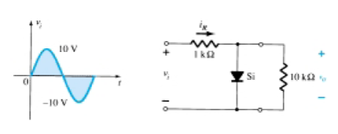
3. Determine vo for each network of Fig. below for the input shown.
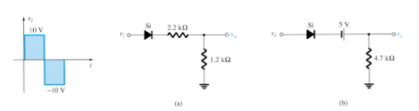
4. Sketch iR and vo for the network of Fig. below for the input shown.
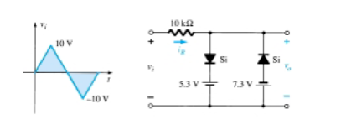
5. What is significance of input and output resistance in a voltage amplifier.
6. Draw a negative clamper and explain its working along with the waveform
7. Draw the low frequency small signal model of a transistor in CE configurations and explain significance of each model.
8. What is Q point of operation of the transistor? What is the region of operation of the transistor when it is working as an amplifier?
9.Explain the significance of coupling and the bypass capacitors in a CE amplifier.
10. Draw the output characteristics of CE configuration and mark its regions of operation.
11.What is biasing? Explain its significance
12. Sketch the high frequency re model of a transistor and explain in brief.
13. Discuss the effect of coupling capacitors on low frequency response of BJT amplifiers.
14. Justify why the clamping circuit is also called a dc inserter?
15. Evaluate the equations for voltage gain , current gain, input impedance and output impedance for a BJT for CE configuration using re model.
16. Evaluate the expression for Ri, Ai, Av and Ro for CE amplifier with un bypassed Re.
17. Explain the principle of clamping. What is the need for a shunting resistor R in parallel with the diode in the basic clamping circuit?
18. Estimate the gain of an amplifier at frequency = 100kHz ,if an Amplifier 3 dB gain is 200 and higher cut-off frequency is 20kHz.
19. For an amplifier, midband gain is 100 and lower cut-off frequency is 1kHz. Estimate the gain of an amplifier at frequency = 20Hz.
20. Determine the dc bias voltage V_{CE} and the current I_{C} for the voltage-divider configuration given below.
21. Determine DC bias voltage V_{CE} and current Ic for the self-bias circuit with V_{cc} =22V, R_{c} = 10KΩ, R₁ = 37KΩ, R₂ = 3.9KΩ, R_{E} = 1.5KΩ, β = 160, If the transistor is replaced by β = 50, Determine new Q points, Assume Silicon transistor. Comment on result .
22. A voltage divider bias CE amplifier has VCC = 14V , R1 =33KΩ, R2=6.8KΩ, RC= 1KΩ, RE =470Ω. The silicon transistor used has a β=100, CC1 =0.01µf,CC2= 0.1 µf , CE= 47µf. With the help of re model find the voltage gain, input impedance , output impedance.
23. Given the input signal shown in the figure (Vi=20sinwt) ,analyze and design a circuit to eliminate the noise , justify your answer.

-20 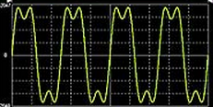
24. For the following transfer characteristics identify and analyze the circuit, also obtain the output wave form if the input wave form is 10sinwt.(assume Si diode)

Vo

Vi
-4 5

25. Design a suitable circuit for the block shown below which has input and output waveforms as indicated
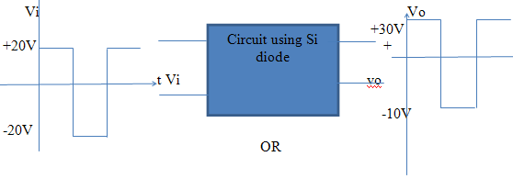
26. Determine the following for the voltage-divider configuration of Fig given below using the approximate approach: (a) IC. (b) VCE. (c) IB. (d) VE. (e) VB.

27.For the circuit shown below, determine the transfer characteristics and sketch the output waveforms.

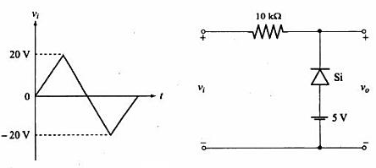
28.For the circuit shown below sketch the output waveform for the given input signal.
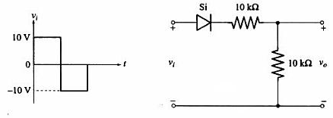
29.For the diode clipping circuit shown below, draw the input and output waveforms for:
a) R=100Ω b) R=1KΩ c) R=10kΩ given vi=20Sinωt and V_{r}=10V Assume r_{f}=100Ω,Rr=∞ and V_{k}=0
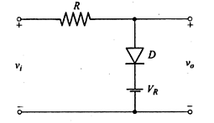
30.Sketch the output voltage waveform over the input voltage waveform for the circuit shown below given the input varies linearly from 0 to 150 V. Assume ideal diodes.
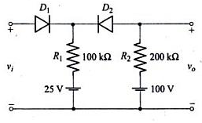
31. The circuit shown is used to square a 10kHz sinusoidal with a peak amplitude of 50V.Find Vr1 and Vr2, if it is desired that the output voltage be flat for 90% of the time. Assume rf=100Ω,Rr=100k Ω for the diodes. What is the reasonable value of R?
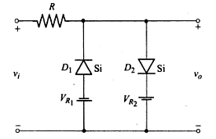
32.Plot the transfer characteristic of the circuit shown assuming ideal diodes and write the transfer characteristic equations. Sketch v0 if vi=20Sinωt.
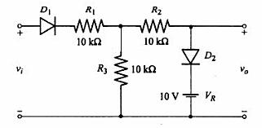
33.For the circuit shown below, find and plot the waveform of vo for the input indicated.
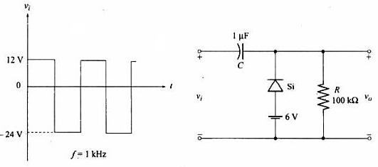
34.For the circuit shown below, find and plot the waveform of vo for the input indicated assuming ideal diode.
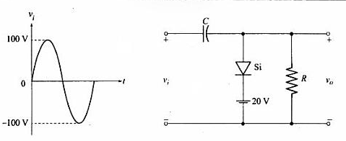
35.The input to a clipping circuit is a sine wave of peak value 25V.Design the component values such that the output should have its positive peak clipped at15V and negative peak at 18V.
36.Design the values of R and C for a clamping circuit for which the input signal is a square wave of frequency 1KHz.
37. Design a clamping circuit to obtain an output with positive peak at 20 V and negative peak at -10V.The input is a square wave of ±15V at 1KHz.Assume silicon diode.
38.Sketch and explain the circuit of a double ended clipper using Si diodes which limits the output between ± 10V.
39. Sketch and explain the circuit of a double ended clipper using Si diodes which limits the output between 5V and 8V.
40.Assuming an ideal diode, draw the output voltage waveform for the input signal given below.
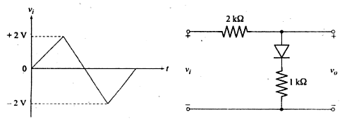

Questions On Feedback Amplifiers
- What are the effects of negative feedback? Explain.
OR
1. Discuss the advantages and disadvantages of –ve feedback.
2.How do you classify the amplifiers based on input and output impedances ? Explain.
3.Write the block diagram of the following indicating A, Af and β .
a.Voltage series feedback amplifier
b.Voltage shunt feedback amplifier
c. Current series feedback amplifier
d.Current shunt feedback amplifier
4.Derive the expression for Af, Rif and Rof for the above amplifiers?
5. An amplifier without feedback has a transfer gain of -2000.The transfer gain changes by 20% due to temperature. If negative feedback with β=-0.1 is given, Calculate the change in the gain of the feedback amplifier? (Ans:1+A β =201,Change in gain=0.099%)
Solution: A=-2000, β=-0.1, 1+A β =201, dA_{f}/A_{f}= (dA/A)/( 1+A β)=0.099%
6.Calculate the gain of a negative feedback amplifier having A=-2000, if the feedback factor is 20%?
(Ans: β=-0.2, 1+Aβ=401, Af= A/(1+Aβ)= -4.98)
7.Given A, β,Ri, Ro And BW, Find A_{f}, Rif, Rof and BWf for the following.
A.Voltage series feedback amplifier
B. Voltage shunt feedback amplifier
C. Current series feedback amplifier
D.Current shunt feedback amplifier
8. Draw the practical circuits for the following
A. Voltage series feedback amplifier
B. Voltage shunt feedback amplifier
C. Current series feedback amplifier
9.The following data is available for Voltage series feedback amplifier RB =50k ohm, RE =1k ohm, RC =1k ohm ,hie =2k ohm, hfe = 150 .Calculate
- Av and Avf.
- Ri and Rif.
- Ro and Rof.
Write the circuit.
Ans: a) 75 & 0.986 b)1.923k ohm & 146.148 k ohm c)1 k ohm & 13.15 ohm Solution: (a)A_{V}=h_{fe}R_{E}/h_{ie}, A_{Vf}=Av/(1+Aβ)
(b) R_{i}=R_{B} parallel hie, Rif=Ri(1+A_{V}β)
(c)R_{O}=R_{E}=1KΩ ,R_{O}=R_{O}/(1+Aβ)
10.For the current series feedback amplifier, calculate the following. Write the circuit.
- Desensitivity Factor
- Transfer gain with feedback.
- Voltage Gain with & without feedback.
- Input resistance with & without feedback.
- Output resistance with & without feedback.
11. For transistor used hfe=200, hie=2k ohm, RB =390k ohm, RC =2k ohm, RE =560 ohm, Vcc=16V,Vs=10mV(rms).
(Ans: D=44.75, Af=-1.745m mho, Av=-156.25, Avf=-3.49, Ri=2.56k ohm, Rif=114.56k ohm, Ro=Rc=2k ohm, Rof=89.5k ohm).
Solution:
(a)β= -R_{E}= - 560 ohm
A= - h_{fe}/(h_{ie}+R_{E}), D=1+Aβ

(b)A_{f}=A/(1+Aβ)

(c)Av=A R_{C} ,Av=A_{f} R_{C}

(d)R_{i}=h_{ie}+R_{E}
R_{if}= h_{ie}+ h_{fe} R_{E}

(e)R_{O}=R_{C}
R_{of}=R_{O}(1+Aβ)
12. An amplifier without feedback has a voltage gain of 50, input
resistance of 1 k Ω and output resistance of 2.5 kΩ. The input resistance of the
current-shunt negative feedback amplifier using the above
amplifier with a feedback factor of 0.2, is----------------
13. A transistor current series feedback amplifier has the following data. RB=50KΩ, RC=2.7KΩ, RE=600Ω, VCC=15V, hfe=200, hie=1000 Ω. Determine AV and AVf. Write the practical circuit.
14. Calculate the harmonic distortion components for an output signal having fundamental amplitude of 2.5 V, second harmonic amplitude of 0.25 V, third harmonic amplitude of 0.1 V and fourth harmonic amplitude of 0.05 V.
Also calculate the total harmonic distortion.
Question Bank On Power Amplifiers

.
- How do you classify power amplifiers? Explain.

2.With a neat circuit diagram, waveforms and necessary equations explain the working of :
- Series fed class A amplifier.

- b) Transformer coupled class A power amplifier.

c)

- Transformer coupled class B push pull amplifier.

d) Complementary symmetry class B push pull circuit.

- Derive an expression for conversation efficiency for
- Series fed class A power amplifier
- Transformer coupled class A power amplifier
- Class B power amplifier.

- Why conversion efficiency is low in class A series fed circuit? How it is
improved in transformer coupled circuit?

5.What is distortion in power amplifiers? Define harmonic distortion.

6.Define second harmonic and total harmonic distortion with necessary equations.

7.What is the need of heat sink? Explain.
8. Design a class B power amplifier to have an output power of 30 watt and an efficiency of 69%.Assume the missing data.

Question Bank on MOSFET
- Differentiate between BJTs and FETs
- Explain the physical structure of n – channel enhancement type MOSFET.
OR
Give the construction details of n-channel enhancement type MOSFET.
- With a neat diagram and i_{d}- v_{ds} characteristics explain the operation of n – channel enhancement MOSFET. When
(a)V_{GS} ≤ V_{t}
(b)V_{GS} > V_{t} & V_{DS} < V_{GS} -V_{t}
(c)V_{GS} > V_{t} & V_{DS} ≥ V_{GS} – V_{t}.
- Define the following w.r.t n-channel enhancement MOSFET.
(a)Threshold voltage.
(b)Excess voltage or effective voltage or overdrive voltage.
(c)Cutoff region
(d)Tiode region
(e)Saturation region.
(f)Sub threshold region.
(g)Process transconductance parameter
(h)Aspect ratio
- Derive an expression for i_{D} when the n-channel e-MOSFET operates in
(a)Triode region.
(b)Saturation region.
- Write a note on CMOS.
- Explain the i_{d} -v_{GS} characteristics ( transfer characteristics) of n-channel e-MOSFET in saturation region. Also write its large signal equivalent circuit model.
- Write the simplified circuit symbol for
(a)N-channel e-type MOSFET.
(b)P- channel e-type MOSFET.
- With a neat circuit diagram and i_{d}-V_{ds} characteristics ,explain the working of P-channel e-type MOSFET.
- Explain the drain(i_{d}-v_{ds}) characteristics of CS amplifier.
- Explain the drain(i_{d}-v_{ds}) and input-output characteristics of CS amplifier.
- Define Q point & load line w.r.t MOSFET CS amplifier.
- What is biasing? What are the types of biasing in MOSFET amplifiers?

- With a neat circuit, explain a ------------- method of biasing technique.
(any one method can be asked)

15.Explain how MOSFET is used as a switch.
16.

EXERCISE PROBLEMS ON UNIT-2 AND UNIT-3
4.1 From the description given below of the operation of MOSFET, for small V_{DS}, we note that I_{D} is proportional to (V_{GS} -V_{t}) V_{DS} . Find the constant of proportionality for the particular device whose characteristics are depicted as shown. Also give the drain to source resistances corresponding to the override voltage (V_{GS}-V_{t}) of 0.5V to 2V.

Solution: a) I_{D}∝(V_{GS} -V_{t}) V_{DS}
I_{D}=K (V_{GS} -V_{t}) V_{DS}
_{K=}$\frac{ID}{ (VGS -Vt ) VDS }$
₌$\frac{0.4}{400}$
_{1mA/V}²
^{b}) Drain to source Impedance= 1/ slope of the graph
^{at}(V_{GS} -V_{t}) = 0.5V
R_{DS}|_{0.5V}=$\frac{1}{(\frac{ID}{VDS})}$
I_{D =} 200 X 10⁻³ ,V_{DS}=0.1 X 10⁻⁴
at(V_{GS} -V_{t}) =2V
^{RDS|2V=}$\frac{ VDS}{ ID}$
I_{D}= 200 X 10⁻³ , V_{DS}=0.4 X 10⁻³
=0.5kΩ
Range of drain to source Impedance= 2kΩ to 0.5KΩ .
4.2 For a 0.8µm process technology, for which t_{ox}= 15nm and µ_{n}=550cm2/Vs, find Cox, kn’ and the over drive voltage Vov=V_{GS}-V_{t}, required to operate a transistor having w/l =20 in saturation with I_{D}=0.2mA. What is the minimum value of V_{DS} needed?
Given: Lmin= 0.8 µm
t_{ox}= 15nm
µn= 550X 10⁻⁴m²V⁻¹s⁻¹
w/l=20
I_{D}=200µA
To find C_{ox}:
C_{ox}=$\frac{€ox}{tox}$= 0.23 x10⁻²Fm⁻2 (€ox= 3.45x 10-11 Fm-1)
To find kn’:
K_{n’}= µ_{n} C_{ox}
= 126.5µAV⁻²
To find V_{ov} in saturation region:
I_{D}= $\frac{Kn'}{2}\frac{w}{l}$ (V_{GS} -V_{t})²= $\frac{Kn'}{2}\frac{w}{l}$V_{ov}²
^{V}_{ov}=$√\frac{2IDL}{WKn'}$= 0.397V
To find V_{DS(min)}:
V_{DS(min)=} V_{GS}- V_{t}= V_{ov}=0.397V= 0.40V

4.3 Use the expression for operation in the triode region to show that n channel MOSFET operated with an override voltage V_{ov}=V_{GS}-V_{t} and having a small V_{DS} across it behaves approximately as a linear resistance r_{DS}
R_{DS}= $\frac{1}{kn^{'}\frac{w}{L}Vov}$
Calculate the value of r_{DS} obtained for a device having kn’=100µA/v² and w/L= 10 when operated with an overdrive voltage of 0.5V
Solution: WKT, resistance of drain to source is given by
R_{DS}=$\frac{Vds}{ID}$|small VDS (1)
In triode region, I_{D} can be expressed as
I_{D}= $\frac{Kn'}{2}\frac{w}{l}$ [(V_{GS} -V_{t})V_{DS}-$\frac{Vds2}{2}$]kn’$\frac{w}{L}$V_{ov}V_{DS (2)}
$\frac{Vds}{ID}$=$\frac{1}{kn^{'}\frac{w}{L}Vov}$
Comparing (1) and (2)
R_{DS}=$\frac{Vds}{ID}$|_{small VDS =} $\frac{1}{kn^{'}\frac{w}{L}Vov}$
To calculate r_{DS}:
Given: kn’= 100µAV⁻²
w/L = 10
V_{ov}=0.5
R_{DS}= $\frac{1}{kn^{'}\frac{w}{L}Vov}$= 2kΩ
4.4 An enhancement type NMOS transistor with V_{t}=0.7V has its source terminal grounded and a 1.5V dc applied to the gate. In what region does the device operate for
a) V_{D=}0.5V b) V_{D}= 0.9V c) V_{D=}3V
solution: The MOSFET operates in- triode region when V_{DS}<V_{Ov} and in saturation region when V_{DS}>V_{OV}
hereV_{ov}=V_{GS}-V_{t}= 1.5 0.7=0.8V
case a) when V_{D}=V_{DS}=0.5V is applied
V_{DS}<V_{GS}-V_{t}
Device operates in triode region.
Case b) when V_{DS}=0.9V
V_{DS}> V_{GS} -V_{t}
Device operates in saturation region.
Case c) when V_{DS}=3V
V_{DS}> V_{GS}-V_{t}
Device operates in saturation region.
4.5 If the NMOS device in 4.4 has µ_{n}C_{ox}= 100µA/V² w= 10µm, L=1µm, find the value of the drain current that results in each of the three cases a) , b), c) specified in 4.4
Solution: a) device operates in triode region
I_{D}= $\frac{Kn'}{2}\frac{w}{l}$ [(V_{GS} -V_{t})V_{DS}-$\frac{Vds2}{2}$]
Here, kn’=µ_{n}C_{ox}= 100µAV⁻²
W/L =10, V_{GS}-V_{t}=0.8V, V_{DS}=0.5V
I_{D=}275µA
b) Device operates in saturation region
I_{D}= $\frac{Kn'}{2}\frac{w}{l}$ (V_{GS} -V_{t})²
=0.5 x 100x10⁻⁶ x10(0.8)²=320µA
I_{D}=320µA
c) device operates in saturation region
I_{D}= $\frac{Kn'}{2}\frac{w}{l}$ (V_{GS} -V_{t})²
I_{D}=320µA
4.6 An enhancement type NMOS transistor with V_{t}=0.7V conducts a current I_{D}=100µA when V_{GS}=V_{DS}=1.2V.Find the value of I_{D} for V_{GS}=1.5V and V_{DS}=3V. Also calculate the value of the drain to source resistance R_{DS} for small V_{DS} and V_{GS}=3.2V.
Solution: when V_{GS}=V_{DS}=1.2V and V_{t}=0.7V
V_{DS}>V_{GS}-V_{t} , device operates in saturation region.
Given: I_{D}=100µA
I_{D}= $\frac{Kn'}{2}\frac{w}{l}$ (V_{GS} -V_{t})²
Substituting the values we get,
= $kn'\frac{w}{l}$ = 800 x10⁻⁶AV⁻²
Now, V_{GS}=1.5V V_{DS}=3V
Again, V_{DS}> V_{GS}-V_{t ,}saturation region
I_{D}= $\frac{Kn'}{2}\frac{w}{l}$ (V_{GS} -V_{t})²
=400 x10⁻⁶(1.5-0.7)²
=256 x10⁻⁶A
I_{D}= 256µA
To find R_{DS}:
R_{DS}= $\frac{1}{kn^{'}\frac{w}{L}Vov}$ =500Ω
R_{DS}=500Ω
4.7 An NMOS transistor is fabricated in a 0.4µm process having µ_{n}C_{ox}=200µA/V² and V’_{A}=50V/µm of channel length. If L=0.8µm and W=16µm, find V_{A} and Λ. Find the value of I_{D} that results when the device is operated with an overdrive voltage V_{OV}= 0.5V and V_{DS}=1V. Also, find the value of r_{o}at this operating point. If V_{DS} is increased by 2V, what is the corresponding change in I_{D} ?
Solution:
Given: µ_{n}C_{ox}= kn’=200µAV⁻²
V’_{A}= 50Vµm⁻²
L=0.8µm
W=16µm
To find V_{A}: V’_{A}=$\frac{Va}{L}$
V_{A}= 50 x 0.8=40V
V_{A}=40V
To find Λ:
Λ=$\frac{1}{Va}$= 0.025V⁻¹
Λ=0.025V⁻¹
To find I_{D:} here V_{DS}>V_{OV} , saturation
I_{D}= $\frac{Kn'}{2}\frac{w}{l}$ (V_{GS} -V_{t})²
I_{D}=0.5mA
To find r_{o}: r_{o}=$\frac{1}{ΛId}$ =80kΩ
r₀= 80kΩ
4.8 The PMOS transistor shown in the figure has V_{t}=-1V ,K_{p}’=60µA/V² and W/L= 10.
a) Find the range of V_{G} for which the transistor conducts.
b) In terms of V_{G} find the range of V_{D} for which the transistor operates in the triode region.
c) In terms of V_{G} find the range of V_{D} for which the transistor operates in the saturation region.
d) Neglecting channel length modulation ( assuming Λ= 0) find the values of |V_{OV}| and V_{G} and the corresponding range of V_{D} to operate the transistor in saturation mode with I_{D}= 75µA.
e) If Λ=-0.02V⁻¹, find the value of r_{o} corresponding to the overdrive voltage determined in d).
f) for Λ= -0.02V⁻¹ and the value of V_{Ov} determined in d) find I_{D} and V_{D}=+3V and at V_{D}=0V; hence calculate the value of the apparent output resistance in saturation . compare to the value found in e).
V_{S}=5V

- To induce a channel we apply gate voltage
V_{GS}≤ V_{t}
V_{G}- V_{S}≤ V_{t}V_{G}≤V_{t}+V_{S}
Here V_{t}= -1V
V_{s}=5V
V_{G}≤ 4V
- To operate in triode region
V_{DS}≥ V_{GS}-V_{t}
V_{D}-V_{S} ≥ (V_{G}-V_{S})-V_{t}
V_{D}≥ V_{G}- V_{t}
V_{D}≥ V_{G}+1 (V_{t}=-1V)
- To operate in saturation region
V_{DS} ≤ V_{GS}-V_{t}
V_{D}-V_{S} ≤ V_{G}-V_{S}-V_{t}
V_{D}≤ V_{G}- V_{t}
V_{D}≤ V_{G}+1 (V_{t}=-1V)
- In saturation mode,
I_{D}= $\frac{Kn'}{2}\frac{w}{l}$V_{ov}²( 1+ΛV_{DS})
| V_{ov}²|= 0.25
| V_{ov}| =0.5V
V_{ov}=V_{GS}-V_{t}
-0.5=V_{GS}+1
V_{GS}=-1.5V
V_{GS}=V_{G}-V_{S}
V_{G}=3.5V
To operate in saturation,
V_{D}≤ V_{G}+1
V_{D}≤4.5V
- Λ=-0.02V⁻¹
V_{A}=$\frac{1}{Λ}$ =50V
R_{o}=$\frac{|Va|}{Id}$= 0.667MΩ
- At V_{D}=+3V
V_{D}< 4.5 MOSFET operates in saturation
I_{D}= $\frac{Kp'}{2}\frac{w}{l}$V_{ov}²( 1+2ΛV_{DS})
V_{DS}=3-5= -2V
I_{D}=78µA
R_{o}=$\frac{|Va|}{Id}$= 0.64MΩ
At V_{D}=0V (V_{D}<4.5V) saturation
I_{D}= $\frac{Kp'}{2}\frac{w}{l}$V_{ov}²( 1+ΛV_{DS})

Substituting values
I_{D}=82.5µA

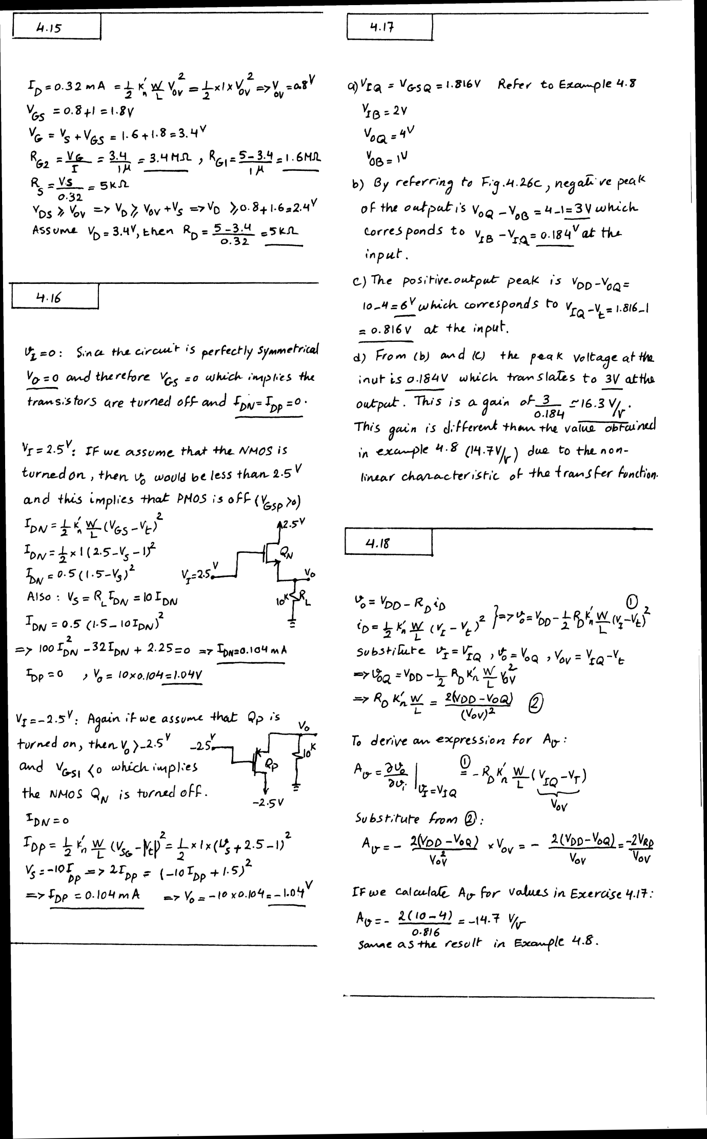
UNIT 5
- Represent The Small Signal Model For An NMOS .
- Derive The Expressions For Transconductance And Voltage Gain For Small Signal Operation Of The Enhancement MOSFET Amplifier.
- Develop the Small-Signal Equivalent-Circuit Models To Show FET As A Voltage-Controlled Current Source.
- Show The Three Different Relationships For Determining Gm .
- Problem (4.30)
- Develop The T Equivalent Circuit Model For The Mosfet.
- Problem (4.69)
- Analyse Small Signal Operation On A Common Source Amplifier, That Has A Signal Source At Its Input In Series With Rsig , And Load Rl Connected At Its Output Terminal. Also Develop an Equivalent Circuit Diagram To Determine The Overall Voltage Gain For The Configuratiojn.
- Repeat The Q(8) For Common – Source Amplifier With A Source Resistance.
- Explain Ic Biasing Circuits And Its Operation.
- Derive The Output Current Equation For A Constant Current Source Mosfet.
- Explain The Output Characteristics Of A Current Mirror Circuit.
- Explain With Equations A Mos Current-Steering Circuit.
- Analyse a Basic Bjt Based current Mirror Circuit.
- Determine The Current Transfer Ratio Of A Wilson Current Mirror.
- Prob (6.24)

- Prob (4.82)
- Characterize And Compare Non unilateral Amplifiers With Transistor Amplifiers.
- Prob (4.30), Exercise
- Example (4.10)

